Tugas Mata Kuliah Analisa R  
**Correlated Data Analysis**



Disusun oleh:

Amila Hanifan Muslimah

**Prodi Magister Epidemiologi**

**Fakultas Kedokteran Universitas Padjadjaran**

**2023**

**Tugas**

Dengan menggunakan data stroke pada link berikut : <http://www.statsci.org/data/oz/stroke.txt> dengan penjelasan data (meta data) dapat dipelajari pada link: <http://www.statsci.org/data/oz/stroke.html> , mengakses dan mendownload dataset ke dalam global environment RStudio.

#1.Mengakses dan mendownload dataset ke dalam global environment RStudio

library(tidyverse)

stroke_long = stroke %>% select(c(1:6,39:46)) %>%

pivot_longer(cols=Bart1:Bart8,

names_to = "time",

names_prefix = "Bart",

values_to = "ability")

names(stroke_long)

glimpse(stroke_long)

Membuat visualisasi grafik garis dari perkembangan nilai kemampuan motorik (functional ability score) dari setiap subyek menggunakan variable bart

#2.A. Membuat visualisasi grafik garis dari perkembangan nilai kemampuan motorik (functional ability score) dari setiap subyek menggunakan variable bart

library(ggplot)

ggplot(stroke_long, aes(x = time,

y = ability)) +

geom_line(aes(group = Subject)) +

theme_classic()+labs( y="Functional abiity score",

x="Time", title="Example Recovery From Stroke")

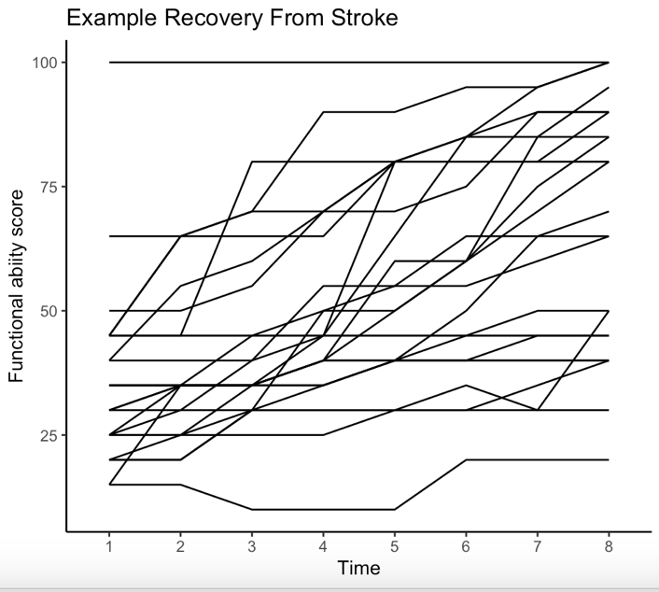

#2.B Membuat visualisasi grafik garis dari perkembangan nilai kemampuan motoric

(functional ability score) dari setiap group menggunakan variable bart

library(ggplot2)

ggplot(stroke_long, aes(x = time,y = ability)) +geom_line(aes(group = Group)) +

theme_classic()+ labs( y="Functional abiity score",

x="Time", title="Example Recovery From Stroke")

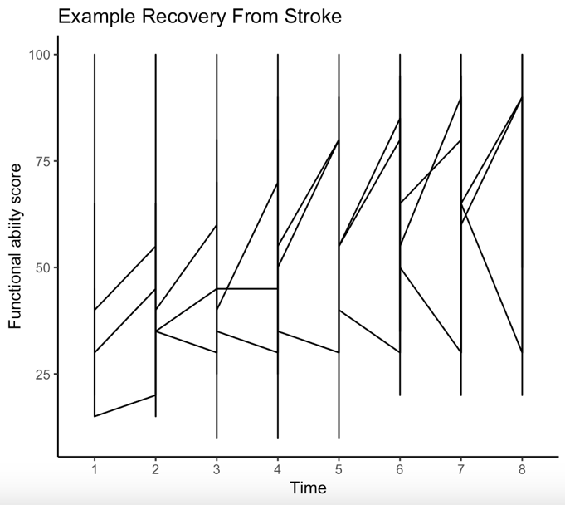

ggplot(stroke_long, aes(x=time, y=ability, group=Subject)) +geom_line() +

facet_wrap(~Group)+ labs( y="Functional abiity score",

x="Time", title="Example Recovery From Stroke")

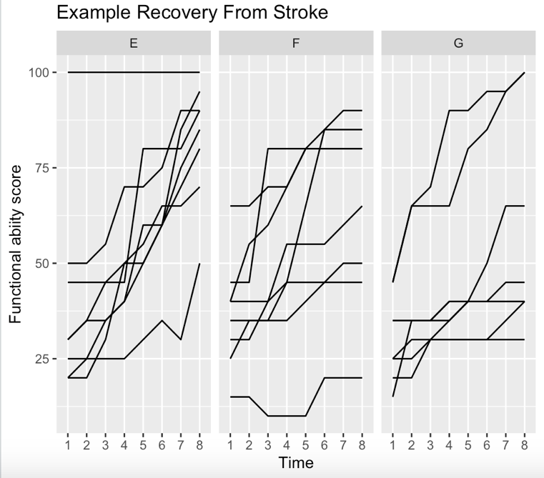

Membuat grafik nilai rata-rata perkembangan fungsi motorik secara total dan masing-masing yang divisualisasikan pada 1 grafik.

#3. Membuat grafik nilai rata-rata perkembangan fungsi motorik secara total dan masing-masing yang divisualisasikan pada 1 grafik.

Average_recovery_score <- stroke_long %>%

group_by(Group, time) %>%

mutate(Average = mean(ability)) %>%

as.data.frame()

Average_recovery_score %>%

mutate(label = if_else(time == max(time), as.character(Group), NA_character_)) %>%

ggplot(aes(x = time, y = Average, group = Group, colour = Group)) + geom_line() + labs( y="Functional abiity score", x="Week", title="Average strokes scores for groups for patients")

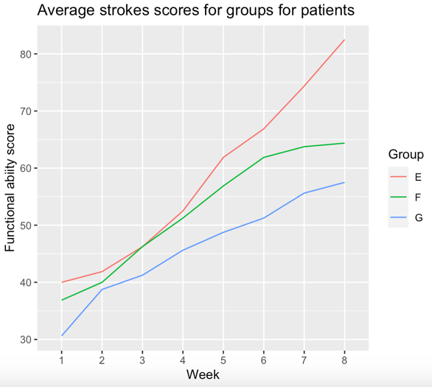

Membuat Matrix Scatter plot dari nilai fungsi motorik antar waktu/pekan

#4. Membuat Matrix Scatter plot dari nilai fungsi motorik antar waktu/pekan.

pairs(~Week1 + Week2 + Week3 + Week4 + Week5 + Week6 + Week7 + Week8, data = stroke_week)

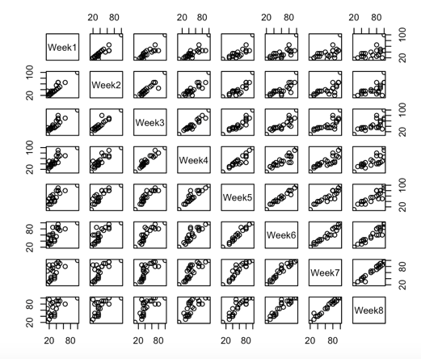

Menghitung dan membuat tabel silang koefisien korelasi nilai fungsi motorik antar waktu/pekan

cor(stroke$Bart1, stroke$Bart2)

cor(stroke$Bart1, stroke$Bart3)

cor(stroke$Bart1, stroke$Bart4)

cor(stroke$Bart1, stroke$Bart5)

cor(stroke$Bart1, stroke$Bart6)

cor(stroke$Bart1, stroke$Bart7)

cor(stroke$Bart1, stroke$Bart8)

cor(stroke$Bart2, stroke$Bart3)

cor(stroke$Bart2, stroke$Bart4)

cor(stroke$Bart2, stroke$Bart5)

cor(stroke$Bart2, stroke$Bart6)

cor(stroke$Bart2, stroke$Bart7)

cor(stroke$Bart2, stroke$Bart8)

cor(stroke$Bart3, stroke$Bart4)

cor(stroke$Bart3, stroke$Bart5)

cor(stroke$Bart3, stroke$Bart6)

cor(stroke$Bart3, stroke$Bart7)

cor(stroke$Bart3, stroke$Bart8)

cor(stroke$Bart4, stroke$Bart5)

cor(stroke$Bart4, stroke$Bart6)

cor(stroke$Bart4, stroke$Bart7)

cor(stroke$Bart4, stroke$Bart8)

cor(stroke$Bart5, stroke$Bart6)

cor(stroke$Bart5, stroke$Bart7)

cor(stroke$Bart5, stroke$Bart8)

cor(stroke$Bart6, stroke$Bart7)

cor(stroke$Bart6, stroke$Bart8)

cor(stroke$Bart7, stroke$Bart8)

|  |  |  |  |  |  |  |  |
| --- | --- | --- | --- | --- | --- | --- | --- |
|  | Week | | | | | | |
|  | 1 | 2 | 3 | 4 | 5 | 6 | 7 |
| Week 2 | 0.93 |  |  |  |  |  |  |
| Week 3 | 0.88 | 0.92 |  |  |  |  |  |
| Week 4 | 0.83 | 0.88 | 0.95 |  |  |  |  |
| Week 5 | 0.79 | 0.85 | 0.91 | 0.92 |  |  |  |
| Week 6 | 0.71 | 0.79 | 0.85 | 0.88 | 0.97 |  |  |
| Week 7 | 0.62 | 0.70 | 0.77 | 0.83 | 0.92 | 0.95 |  |
| Week 8 | 0.55 | 0.64 | 0.70 | 0.77 | 0.88 | 0.93 | 0.98 |

Menghitung intercept dan slope, beserta standar errornya masing-masing,  dari hubungan fungsi motorik dengan waktu/pekan setiap subyek, serta mempresentasikan hasilnya dalam bentuk tabel

ml <- lmList(log(ability) ~ I(time) | Subject, stroke_long)

intercepts <- sapply(ml,coef)[1,]

slopes <- sapply(ml,coef)[2,]

intercepts

slopes

library(lme4)

model <- (lmList(ability ~ time | Subject, data = stroke_gabungan))

summary(model)$coef

|  |  |  |  |  |
| --- | --- | --- | --- | --- |
| Subject | Intercept | (std. error) | Slope | (std. error) |
| 1 | 3.68 | (3.987336) | 3.1 | (0.7896103) |
| 2 | 4.17 | (3.987336) | 2.7 | (0.7896103) |
| 3 | 3.4 | (3.987336) | 2.2 | (0.7896103) |
| 4 | 3.2 | (3.987336) | 3.3 | (0.7896103) |
| 5 | 3.8 | (3.987336) | 1.5 | (0.7896103) |
| 6 | 2.7 | (3.987336) | 1.4 | (0.7896103) |
| 7 | 3.5 | (3.987336) | 1.1 | (0.7896103) |
| 8 | 3.6 | (3.987336) | 1.6 | (0.7896103) |
| 9 | 2.9 | (3.987336) | 4.7 | (0.7896103) |
| 10 | 3.5 | (3.987336) | 2.5 | (0.7896103) |
| 11 | 3.5 | (3.987336) | 9.3 | (0.7896103) |
| 12 | 3.8 | (3.987336) | 3.6 | (0.7896103) |
| 13 | 3.8 | (3.987336) | 3.6 | (0.7896103) |
| 14 | 3.2 | (3.987336) | 1.8 | (0.7896103) |
| 15 | 3.2 | (3.987336) | 3.2 | (0.7896103) |
| 16 | 2.7 | (3.987336) | 8.4 | (0.7896103) |
| 17 | 3.8 | (3.987336) | 5.1 | (0.7896103) |
| 18 | 2.9 | (3.987336) | 2.2 | (0.7896103) |
| 19 | 3.9 | (3.987336) | 3.5 | (0.7896103) |
| 20 | 3.2 | (3.987336) | 1.2 | (0.7896103) |
| 21 | 4.6 |  | 2.5 |  |
| 22 | 2.9 | (3.987336) | 8.8 | (0.7896103) |
| 23 | 3.4 | (3.987336) | 1.5 | (0.7896103) |
| 24 | 3.4 | (3.987336) | 1.5 | (0.7896103) |